**DAILY ONLINE ACTIVITIES SUMMARY**

|  |  |  |  |
| --- | --- | --- | --- |
| **Date:** | 15/07/2020 | **Name:** | Krishnitha |
| **Sem & Sec** | 4th sem, A Section | **USN:** | 4AL18CS039 |
| **Online Test Summary** | | | |
| **Subject** | Operating Systems | | |
| **Max. Marks** | 30 | **Score** | NA |
| **Certification Course Summary** | | | |
| **Course** | Data Security | | |
| **Certificate Provider** | Salseforce | **Duration:** | 3 hrs |
| **Coding Challenges** | | | |
| **Problem Statement:**  Write the java program to sort a stack using recursion. | | | |
| **Status:** Executed | | | |
| **Uploaded the report in GitHub** | | YES | |
| **If yes Repository name** | | <https://github.com/krishnitha/Java-coding> | |
| **Uploaded the report in slack** | | YES | |

**Descriptive Test Details:**

Today we had test in “Operating System” subject. The assessment was based on fourth module of this subject. The test consisted of four questions, each of 7.5 marks.

**Certification Course Details:**

Today I continued the course “Data Security” by Sales Force. Today I learnt about Data security and how to control access to orgs, fields, objects, records. I have completed the course.

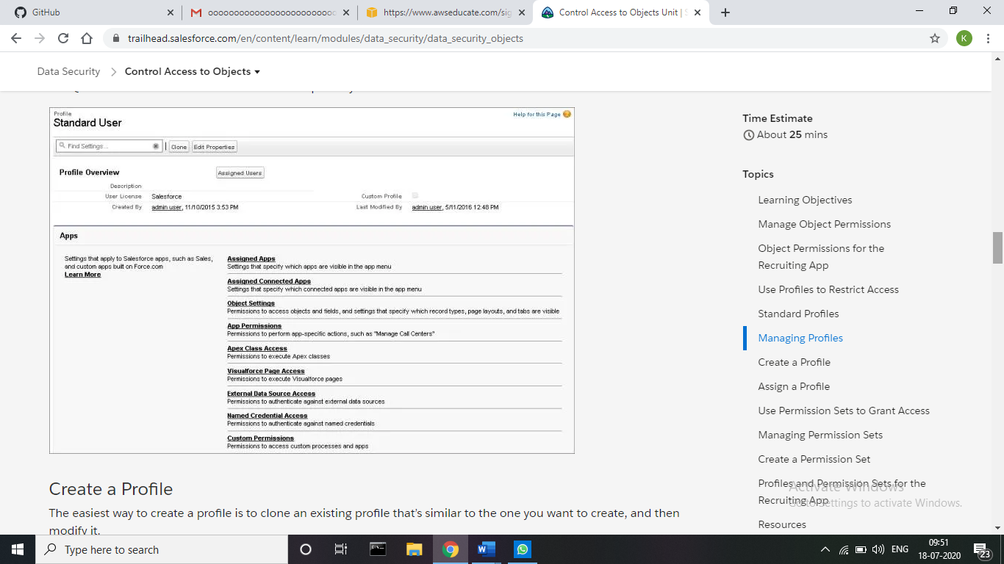

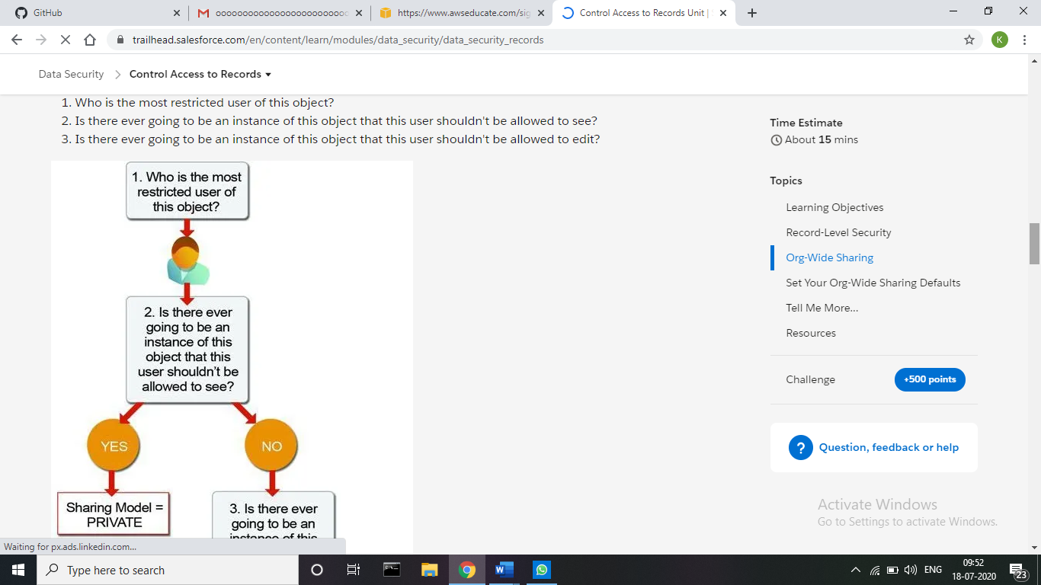

**Coding Challenges Details:**

**Problem:** Write the java program to sort a stack using recursion.

Given a stack, sort it using recursion. Use of any loop constructs like while, for etc is not allowed. We can only use the following ADT functions on Stack S:

is_empty(S): Tests whether stack is empty or not.

push(S): Adds new element to the stack.

pop(S): Removes top element from the stack.

top(S): Returns value of the top element. Note that this function does not remove element from the stack.

**Example:**

Input:

-3 🡨 Top

14

18

-5

30

Output:

30 🡨 Top

18

14

-3

-5

**Solution:** Uploaded it in GitHub

